Computer Language Coding Concepts

Interaction Events
Apart to system events, the next most commonly used group of events may very well be the interaction events.

Interaction events are events that occur when a user for instance clicks a button, or double clicks or presses a keyboard key.

This type of event is more of a controls concept than a coding concept, but they are mentioned here anyway, because they are such a common use of events

Below you will find a simplified overview of the most common interaction events.

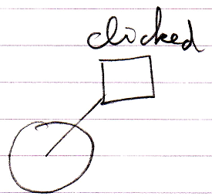 | 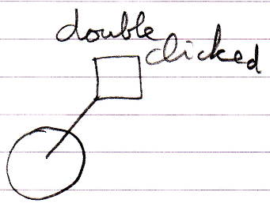
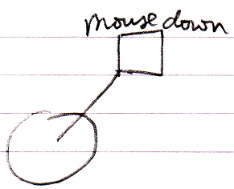 | 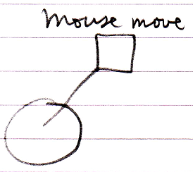 | 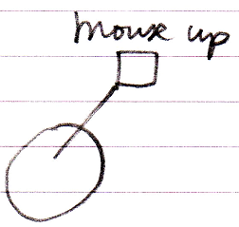
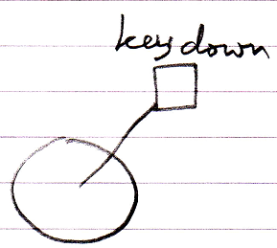 | 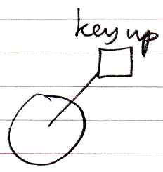

Author & Copyright: Jan-Joost van Zon Date: May 10, 2010 – May 14, 2010 Location: Oosterhout, The Netherlands Status: Finished

